Make an Online Airline Reservation System. The activities of the Online AirlinReservation system are listed below user, admin, LOGIN, MANANGE CLASSES, MANANGE WAITING LIST, MANAGE HOLDS, MANAGE DEADLINES, LOGOUT, using this has a step-by-step process draw a CLASS diagram.

## **Aim**

To develop an **Online Airline Reservation System** that allows users to book flights, manage reservations, and enables administrators to handle flight classes, waiting lists, holds, and deadlines efficiently.

## **Procedure (Step-by-Step)**

### **Step 1: Identify the Key Components of the System**

The system consists of two primary users:

1. **User** (Passengers booking tickets)
2. **Admin** (Manages flight schedules, bookings, and policies)

The system includes the following functionalities:

* **User Login/Registration**
* **Flight Search & Ticket Booking**
* **Class Management (Economy, Business, First Class)**
* **Waiting List Management**
* **Hold Management** (Temporary seat blocking)
* **Deadline Management** (Cancellation and refund policies)
* **Logout**

### **Step 2: Define System Modules and Their Functionalities**

#### **1. User Module**

* **Register/Login**: Users create an account and log in.
* **Search Flights**: Users browse available flights based on date, destination, and class.
* **Book Tickets**: Users select a flight, choose a seat, and make payment.
* **View Booking Details**: Users check their booked flights.
* **Cancel Booking**: Users can cancel tickets if necessary.
* **Logout**: Ends the session securely.

#### **2. Admin Module**

* **Login**: Admin authentication to access the system.
* **Manage Flight Classes**: Add, update, or remove classes (Economy, Business, First Class).
* **Manage Waiting List**: Handles users in the waiting queue for full flights.
* **Manage Holds**: Temporarily reserves seats for specific users.
* **Manage Deadlines**: Defines booking deadlines and cancellation policies.
* **Logout**: Ends the admin session.

### **Step 3: Define System Flow**

1. **User logs in** → Searches for flights → Selects a flight → Makes payment → Ticket is booked.
2. **If flight is full** → User is added to the waiting list.
3. **Admin logs in** → Updates flight availability → Manages waiting lists and holds.
4. **User or Admin logs out** → Session is terminated securely.

Class diagram

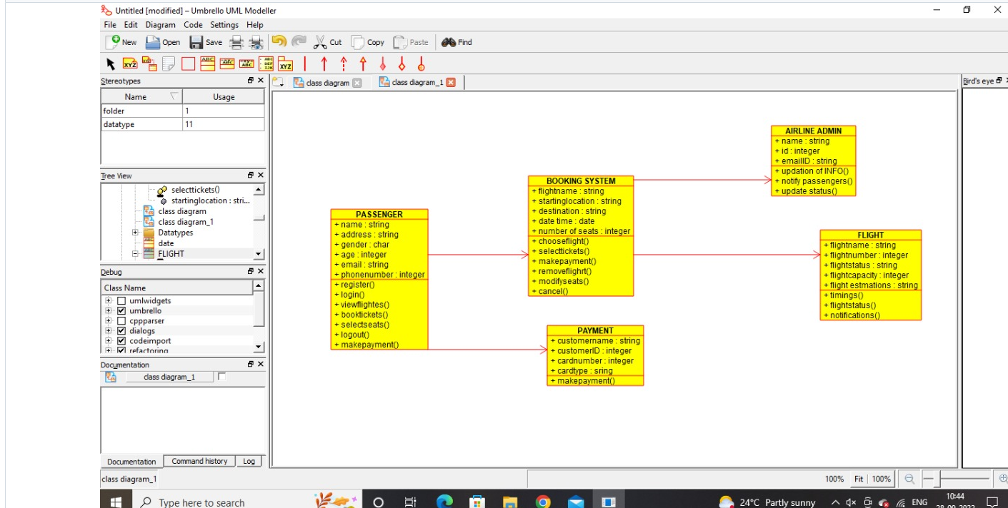

## **Result**

The **Online Airline Reservation System** successfully facilitates **flight bookings, ticket management, and administrative operations**. It provides a seamless experience for passengers to search and book flights while enabling administrators to manage airline operations efficiently. The system enhances **convenience, reduces manual efforts, and improves overall efficiency** in airline reservations.